**Software Engineering Tools Lab**

**Assignment No-6**

(Module 4- Version control)

**PRN: 2019BTECS00017**

**Full name: Muskan Raju Attar**

**Batch: T1**

**Q 1. What is Microsoft’s VSS?**

The Volume Shadow Copy Service (VSS), which was introduced in Windows Server® 2003, facilitates the conversation between these components to allow them to work better together. When all the components support VSS, you can use them to back up your application data without taking the applications offline.

Provide the information of VSS tool with respect to below points.

* Owner/ developer
* Brief information/introduction

Microsoft Visual SourceSafe (VSS) is a discontinued source control program oriented towards small software development projects. Like most source control systems, SourceSafe creates a virtual library of computer files. While most commonly used for source code, SourceSafe can handle any type of file in its database, but older versions were shown[1][2] to be unstable when used to store large amounts of non-textual data, such as images and compiled executables.

* Basic operations involved
* Advantages
* Disadvantages

VSS is prone to corruption causing the DB to have to be rebuilt.

It does not perform well if you have a lot of code in it it will be very slow.

No searching basic tree structure.

**Q 2. Create a SVN repository and perform below operations on that repository using SVN. Also explain below operations.**

Create the repository:

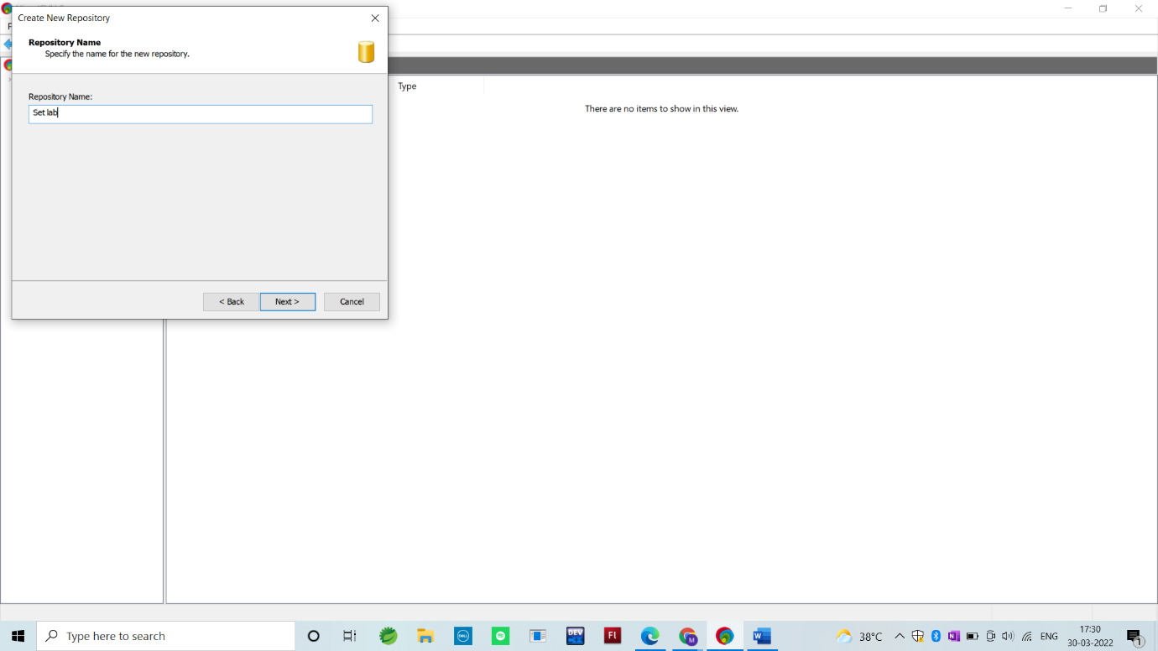

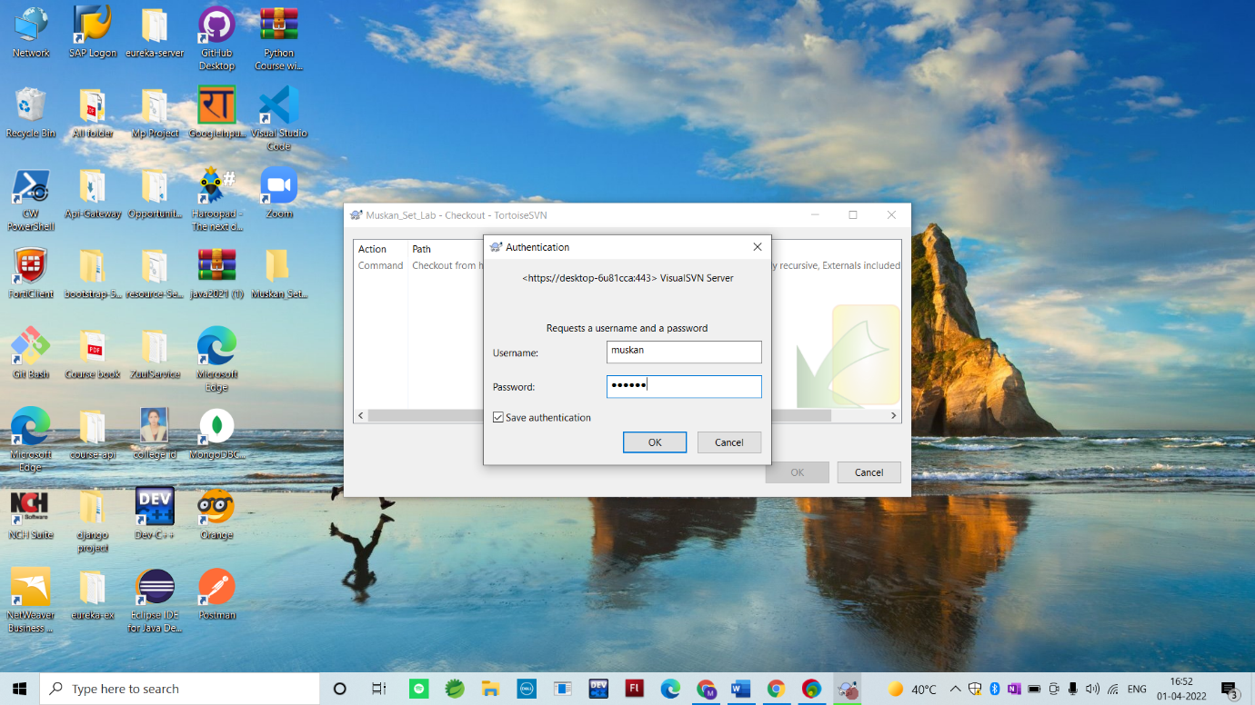

Commit:

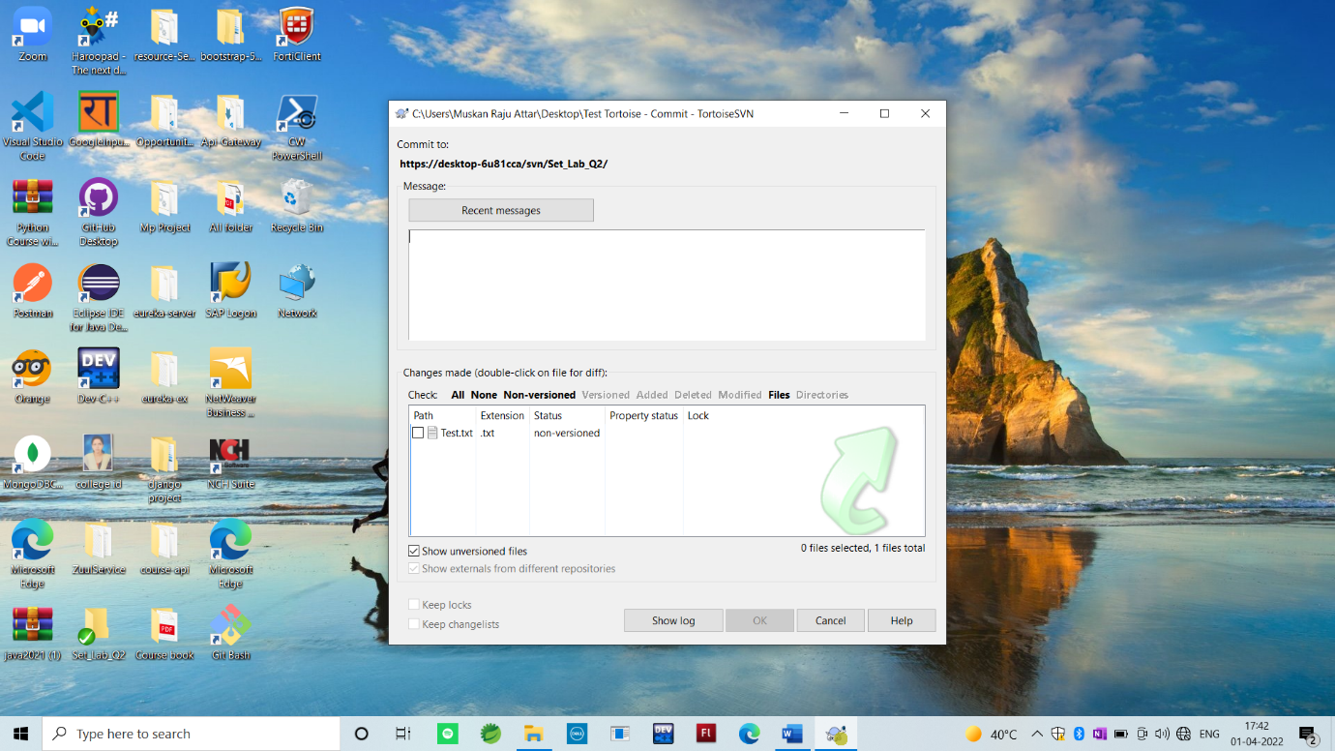

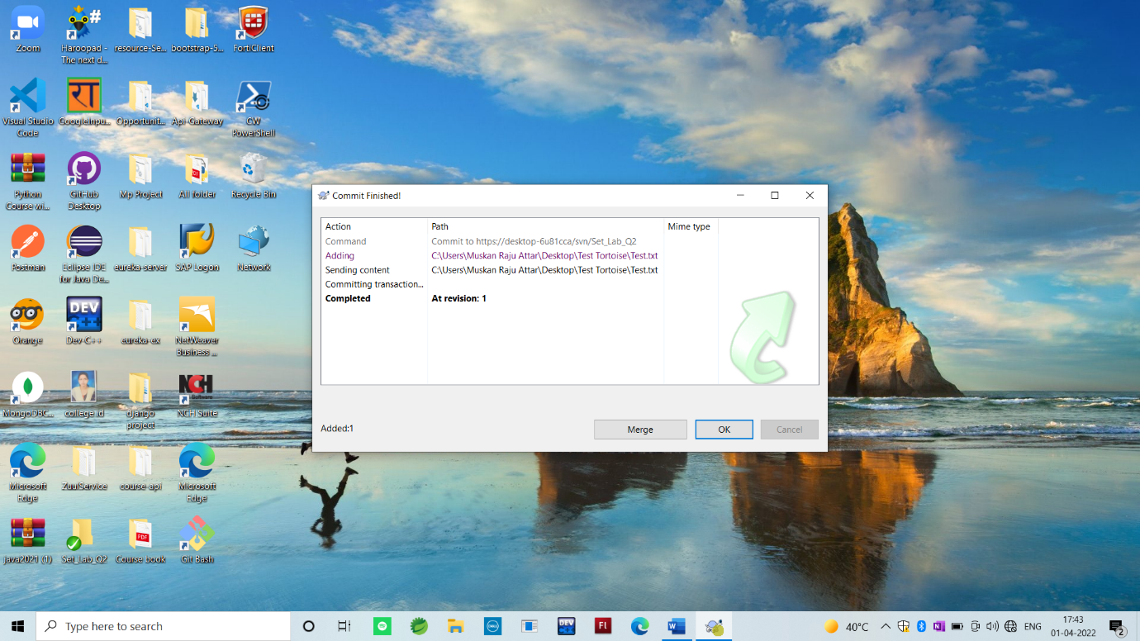

Import:

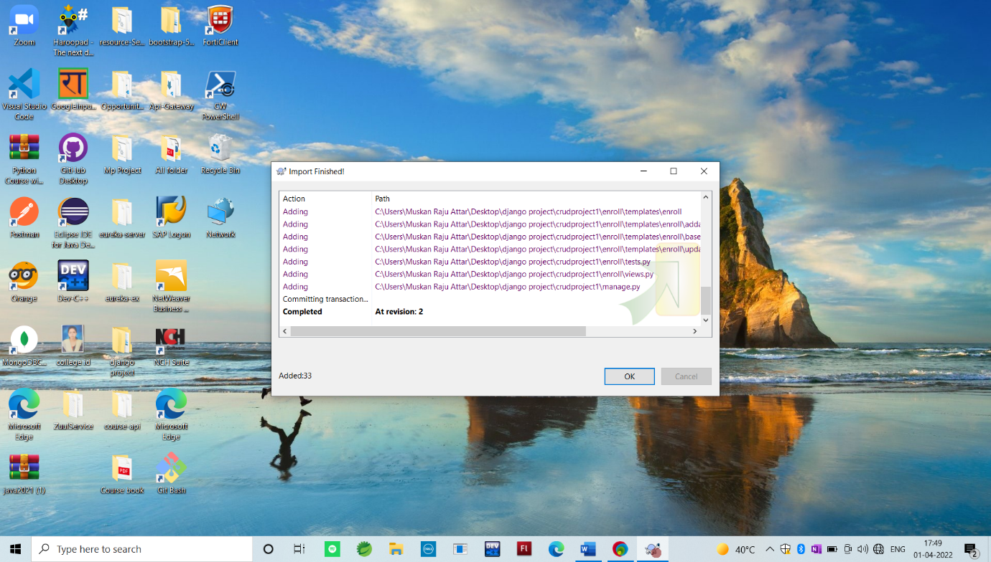

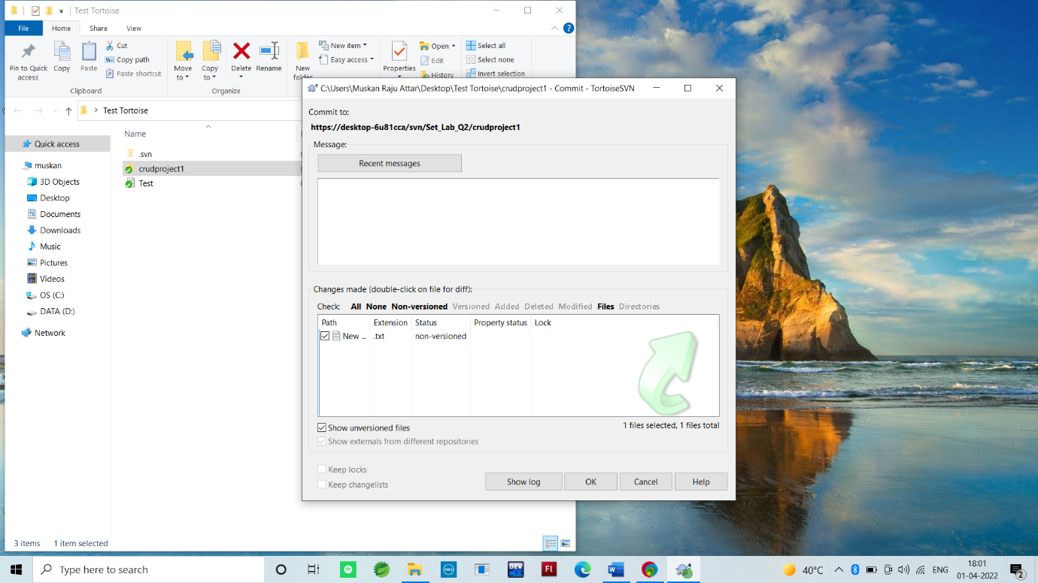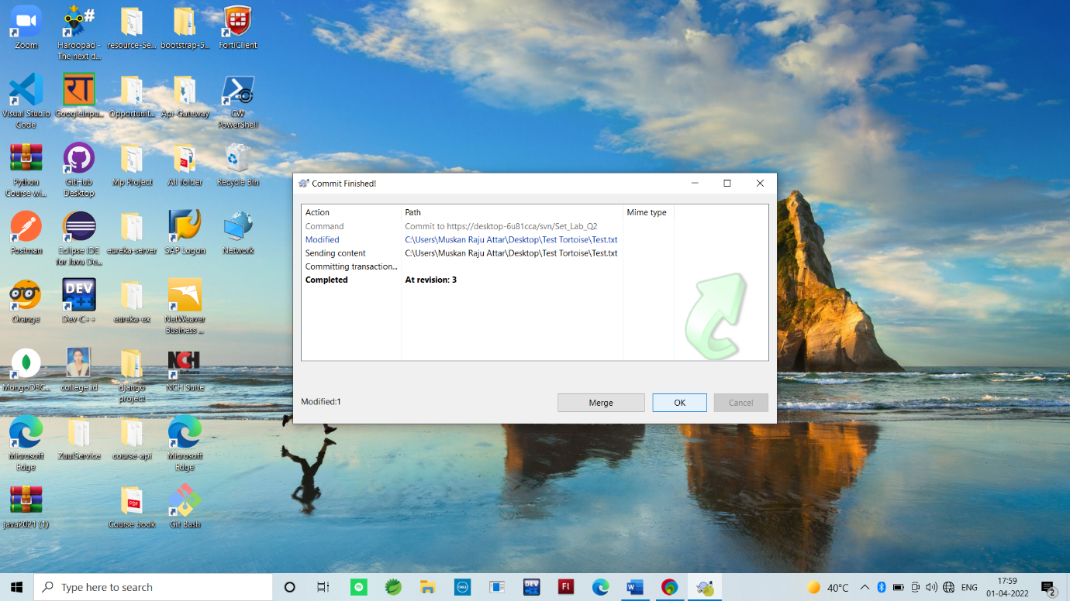

Copy:

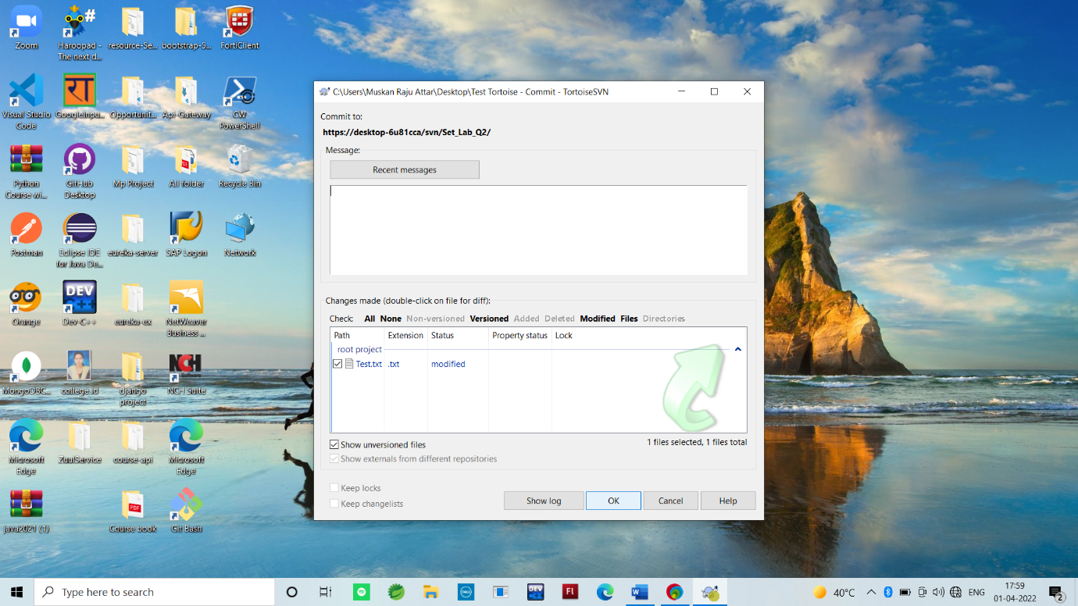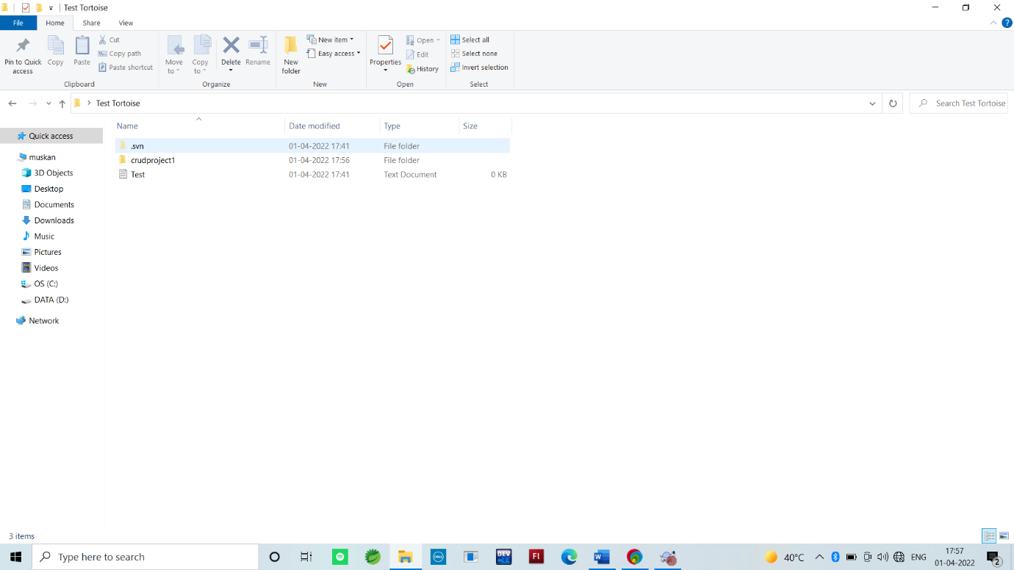

Checkout:

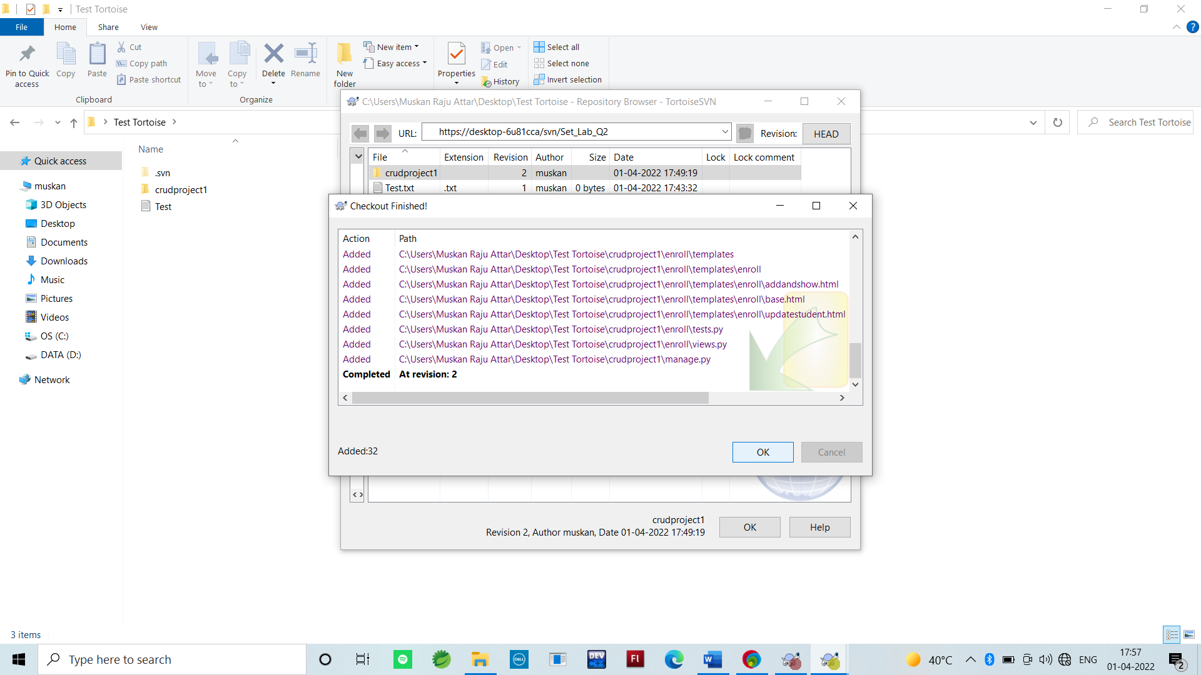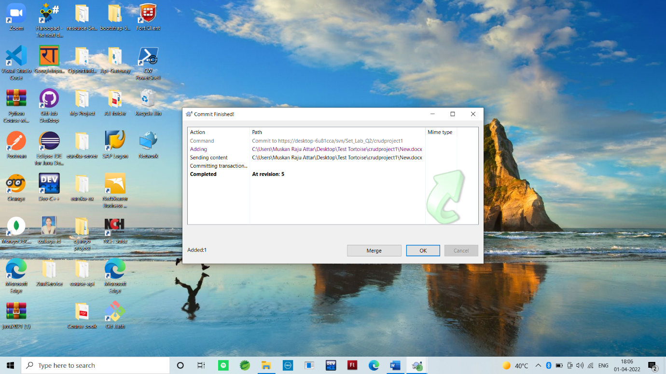

Revert:

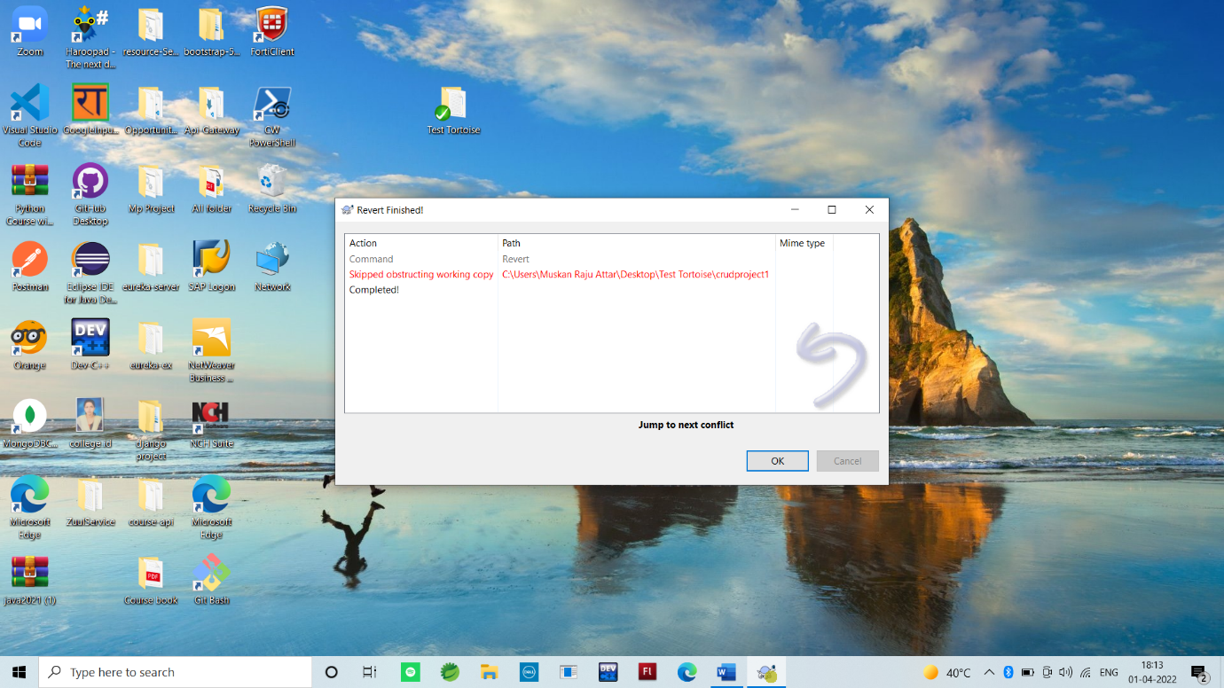

**Q 3. Perform below operations using CVS**

* cvs checkout
* cvs update
* cvs add
* cvs remove
* cvs commit

**Q 4. Differentiate Between The Git & SVN Repository?**

GIT vs SVN

* Git is open source distributed vice control system developed by Linus Torvalds in 2005. It emphasis on speed and data integrity

Apache Subversion is an open source software version and revision control system under Apache license.

* Git has a Distributed Model.

SVN has a Centralized Model.

* In git every user has their own copy of code on their local like their own branch.

In SVN there is central repository has working copy that also make changes and committed in central repository.

* In git we do not required any Network to perform git operation.

In SVN we required Network for runs the SVN operation.

**Q 5. What is “branch”, “tag” And “trunk” In SVN?**

Trunk would be the main body of development, originating from the start of the project until the present.

Branch will be a copy of code derived from a certain point in the trunk that is used for applying major changes to the code while preserving the integrity of the code in the trunk. If the major changes work according to plan, they are usually merged back into the trunk.

Tag will be a point in time on the trunk or a branch that you wish to preserve. The two main reasons for preservation would be that either this is a major release of the software, whether alpha, beta, RC or RTM, or this is the most stable point of the software before major revisions on the trunk were applied.

**Q 6. How CVS is different from SVN?**

CVS and SVN are two such version control systems used in software development. The main difference between CVS and SVN is that the CVS is a free, client-server based version controlling system while SVN is an advanced and newer software version controlling system than CVS.